Quarto Book Prototype
ASKCR
2023-04-26
Table of contents

1. Title: Quarto Book Prototype
Author: Anna SKC Rahr
ORCID:
Date: 2023-04-26
DOI: 10.5281/zenodo.7852205
Repository URL: https://github.com/calnfynn/catalogue-003

1.1 Based on Baroque AI: Publication Prototype

1.2 Part of the series: Baroque TOC
Programme instructions
2023-03-17
This work is licensed under a Creative Commons Attribution-ShareAlike 4.0 International License.
Book cover: Reworking of Waves. Creative Commons CC0 1.0 Universal Public Domain Dedication. This file was donated to Wikimedia Commons as part of a project by the Metropolitan Museum of Art.

This work is licensed under a Creative Commons Attribution-ShareAlike 4.0 International License.

2. Colophon
Fork title: Quarto Book Prototype
Author: Anna SKC Rahr
Date: 2023-04-26
DOI: 10.5281/zenodo.7852205
Repository: https://github.com/calnfynn/catalogue-003
PUBLISHING FROM COLLECTIONS USES OF COMPUTATIONAL PUBLISHIGN AND LINKEDOPEN DATA
Open Science Lab - TIB Hannnover
First published 2023-03-30
Copyright © The Authors 2023 Licensed as https://creativecommons.org/licenses/by-sa/4.0/
DOI: https://doi.org/10.5281/zenodo.7701161

3. Exploring the Dimensional Realm: An Introduction to Stereoscopy in Photography
Source: ChatGPT

3.1 Introduction
Photography has long been cherished for its ability to capture moments and freeze them in time. However, there exists a remarkable technique that goes beyond mere two-dimensional representations. Stereoscopy, a captivating field of photography, allows us to perceive images in three dimensions, recreating depth and enhancing the immersive experience. In this article, we will delve into the intricacies of stereoscopy and explore how it has revolutionized the way we view and appreciate photographs.

3.2 Understanding Stereoscopy
At its core, stereoscopy aims to mimic the way our eyes perceive the world. It relies on the concept of binocular vision, where each eye captures a slightly different image, and our brain combines these two perspectives to create a sense of depth. Similarly, stereoscopy captures two offset images and presents them in such a way that our brain fuses them together, resulting in a perception of depth and realism.

3.3 The Stereoscopic Effect
The key to creating a stereoscopic effect lies in the separation of the two images. Photographers achieve this by using specialized equipment like dual-lens cameras or by taking two separate shots, mimicking the disparity between the perspectives of our eyes. These images, known as “stereopairs” or “stereographs,” are then presented in a way that allows the viewer to experience the depth of the scene.

3.4 Types of Stereoscopic Photography
Stereoscopic photography encompasses various techniques and formats. One such example is anaglyph 3D, where images are composed of two color channels (typically red and cyan) that, when viewed through color-filtered glasses, merge to form a 3D image. Another popular technique is polarized 3D, which employs polarized filters on both the camera lenses and the viewing glasses to separate and recombine the images, creating a three-dimensional effect. Other methods include cross-viewing (also known as freeviewing), where viewers train their eyes to focus differently, and autostereograms, which use repeating patterns to create hidden 3D images.

3.5 Applications of Stereoscopy
Stereoscopy has found its way into various fields beyond photography. In medicine, it aids in visualizing complex anatomical structures, enabling surgeons to plan procedures and enhance their precision. Archaeologists and historians also employ stereoscopy to analyze artifacts and explore ancient sites in virtual three-dimensional environments. Additionally, stereoscopic imagery has gained popularity in entertainment, with movies and video games utilizing the technique to provide viewers with a more immersive experience.

3.6 Conclusion
Stereoscopy in photography opens a door to a world beyond the constraints of flat images, allowing us to explore depth, perspective, and realism. It offers a unique way to engage with photographs and enhances our understanding and appreciation of the visual medium. As technology advances, the potential for stereoscopy continues to grow, promising even more exciting applications and experiences for both creators and viewers alike.

4. A Catalogue of Stereoscopic Images

4.1 Schliersee und Tegernsee
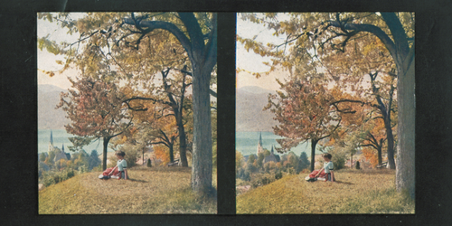
Wikidata link: http://www.wikidata.org/entity/Q118720298
Materials: cardboard
Year: 1907
Location: Adolf-Würth-Zentrum für Geschichte der Psychologie

4.2 [Mainufer in Würzburg]
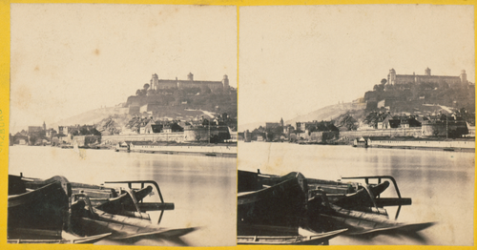
Wikidata link: http://www.wikidata.org/entity/Q118720301
Materials: cardboard, albumin paper
Year: 1860
Location: Adolf-Würth-Zentrum für Geschichte der Psychologie

4.3 Dolomiten II
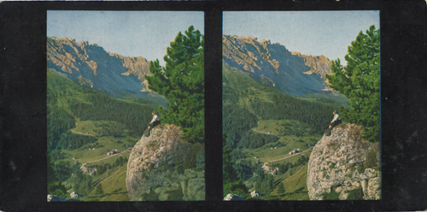
Wikidata link: http://www.wikidata.org/entity/Q118720297
Materials: cardboard
Year: 1907
Location: Adolf-Würth-Zentrum für Geschichte der Psychologie

4.4 Mondkugel
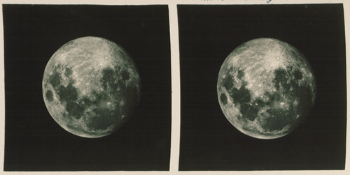
Wikidata link: http://www.wikidata.org/entity/Q118720299
Materials: photographic paper
Year: N/A
Location: Adolf-Würth-Zentrum für Geschichte der Psychologie

4.5 Die Kaisergalerie
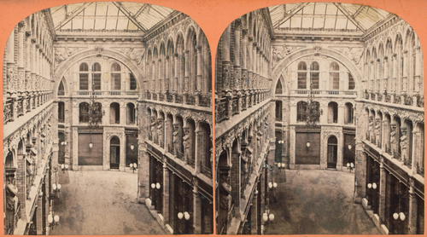
Wikidata link: http://www.wikidata.org/entity/Q118720300
Materials: cardboard, albumin paper
Year: 1864
Location: Adolf-Würth-Zentrum für Geschichte der Psychologie

